React Basic Hello Word program

1. Dw & install node version any(latest pref)

node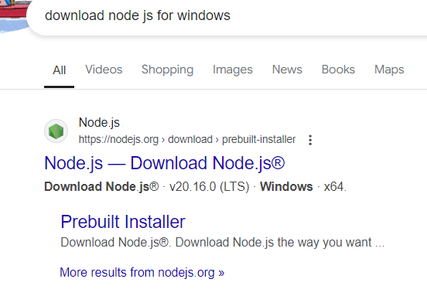

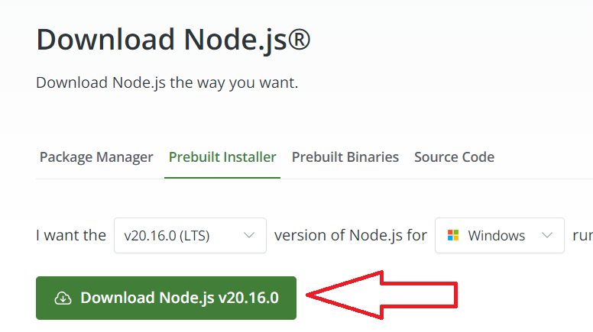

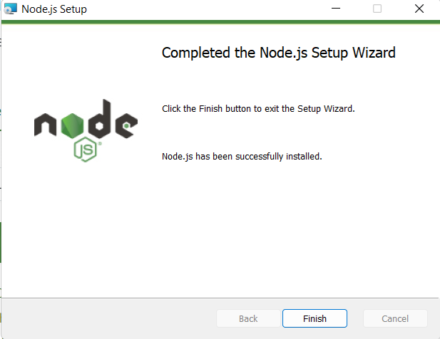

To verify open command line

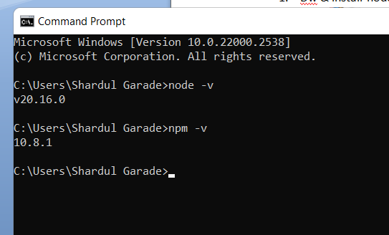

Run following command on powershell

Set-ExecutionPolicy RemoteSigned -Scope CurrentUser

Make a folder(**react-applications**) // use any name

Open the **react-applications** folder in vscode

Open terminal

cd react-applications **//make sure the location is showing on the prompt**

D:\ **react-applications** >

D:\ **react-applications** > npm create vite@latest

Give the project name “first-react-project”

Choose React

Choose JavaScript

D:\ **react-applications** > cd first-react-project

D:\ **react-applications\first-react-project** > npm i

D:\ **react-applications\first-react-project** > npm run dev

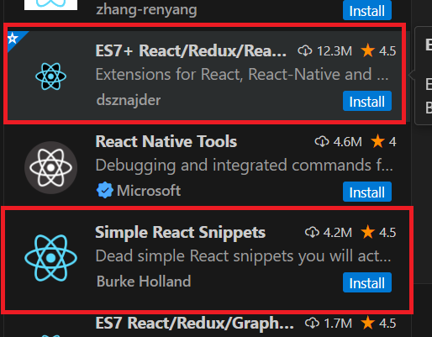

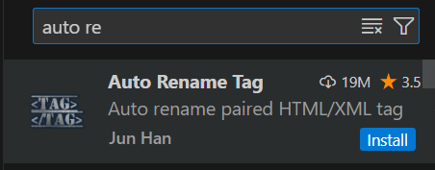

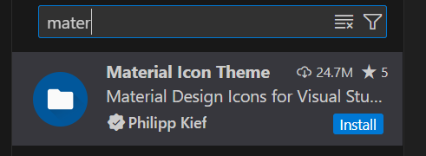

Clear the app.css

Clear the index.css

Clear the app.jsx

Install the ES7+React/Redux vendor dsnnajder

In App.jsx write rafce select

import React from 'react'

const App = () => {

  return (

    <div>Welcome to React JS ITV</div>

  )

}

export default App